Research

*Note: the following are not necessarily restaurant booking websites, though they all have features and/or visual elements in common with the intended implementation of our site. Good and bad features take into account the site type., for example, a lack of search filters may be ignored on the basis of the analysed site type.*

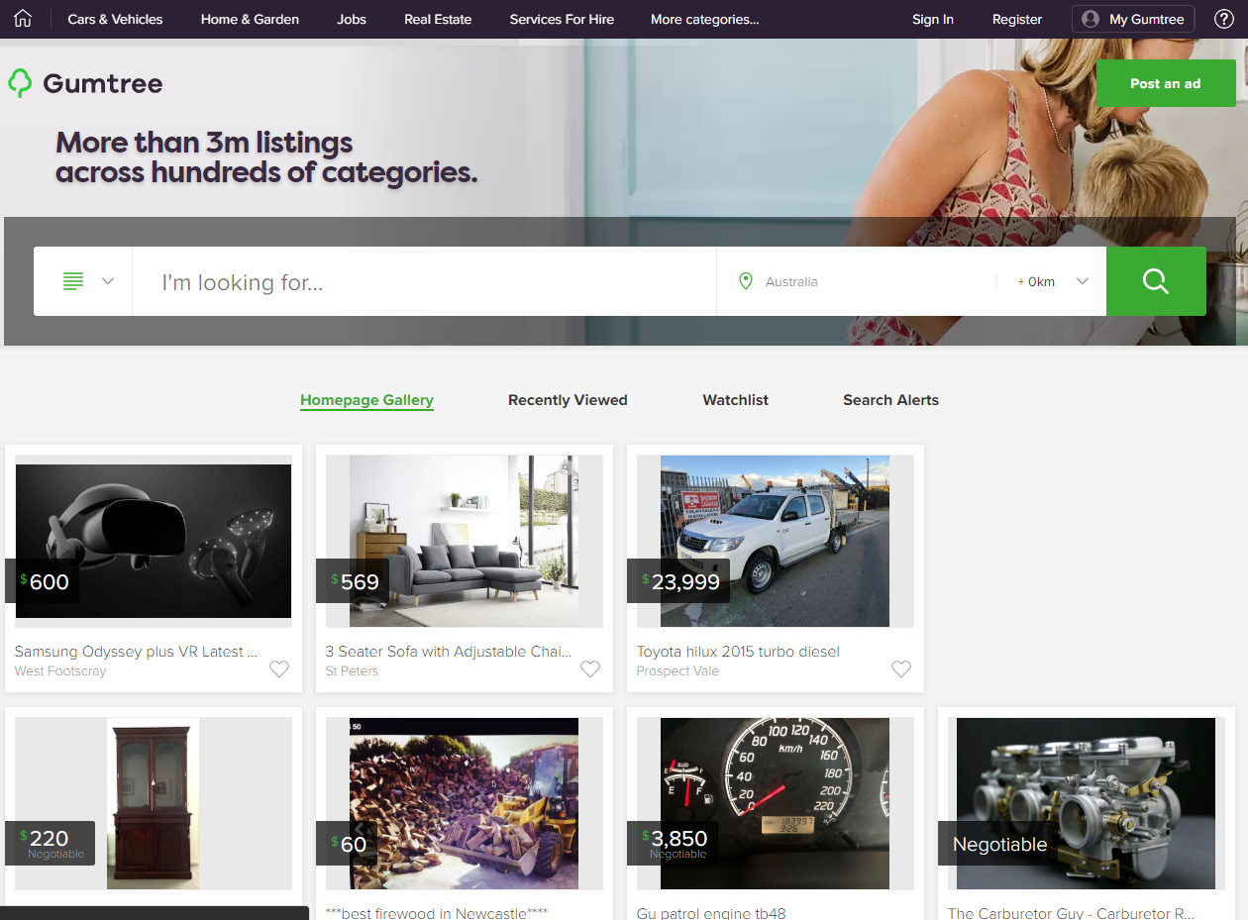

|  |  |
| --- | --- |
| Good | Bad |
| * Emphasised search bar with minimal input. * Dynamic actions are towards the top right as is standard (i.e. ‘Sign In’, ‘My Gumtree’, ‘Post an ad’). | * The distance dropdown, though not required of this project, defaults to 0km, which would, in theory, yield no results. It would be better to default this value to the most common user choice, and disallow an input of 0km, or replace it with <1km. |

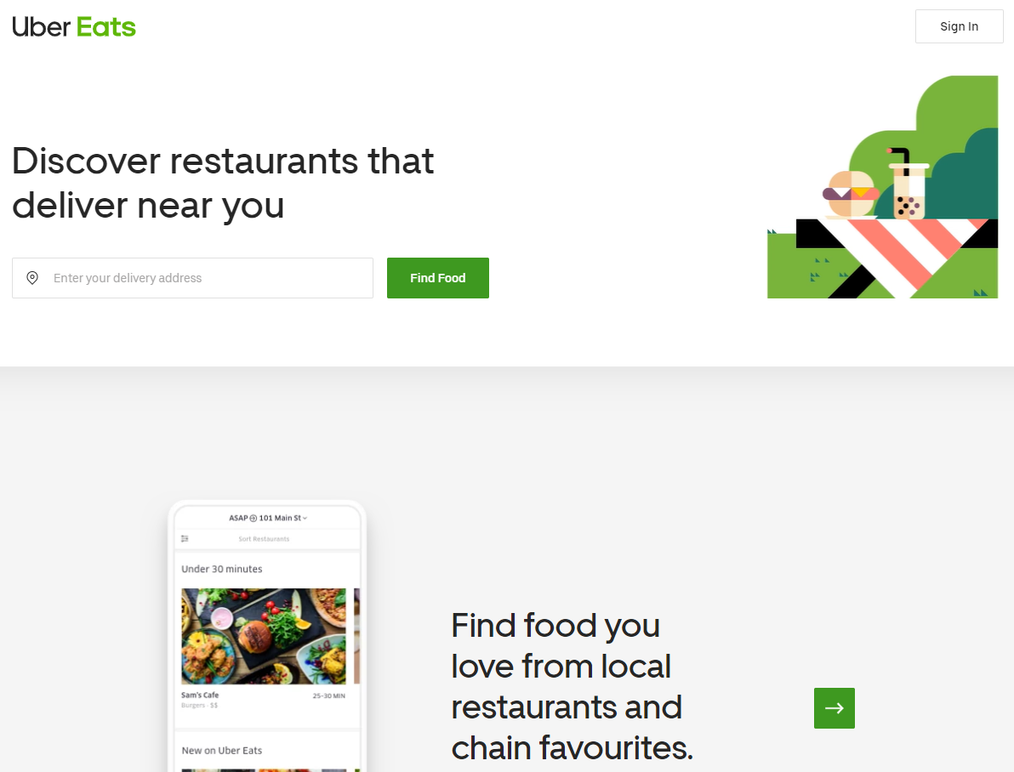

|  |  |
| --- | --- |
| Good | Bad |
| * Emphasised search bar with minimal input. * Dynamic actions are towards the top right as is standard (‘Sign In’). * Minimal visual clutter. | * No food photography as a visual appetiser. |

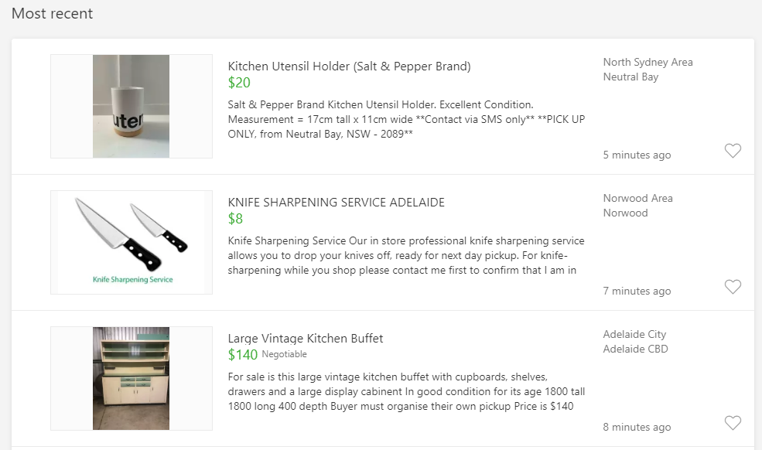

|  |  |
| --- | --- |
| Good | Bad |
| * Minimal information. * Visual and textual information. | * No display of customer feedback. |

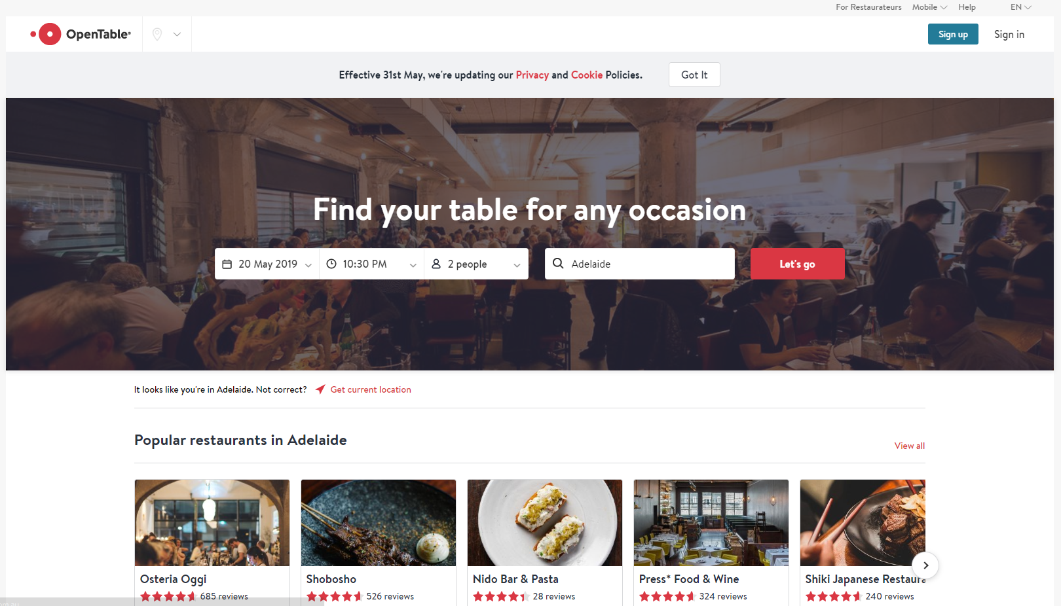

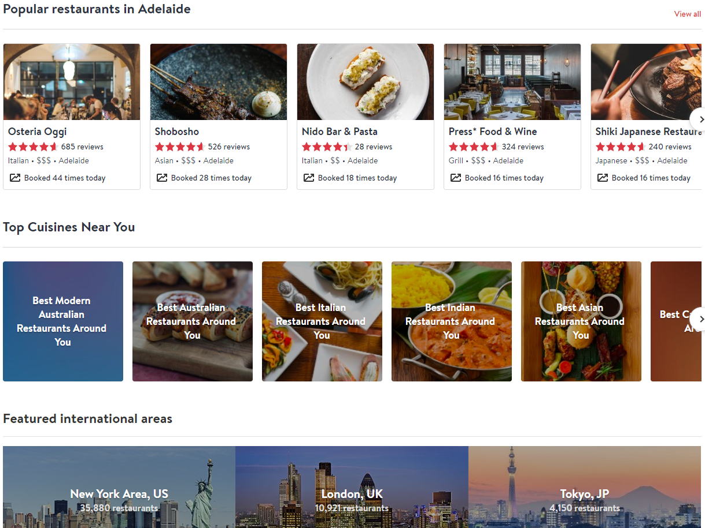

*Note: the above are two images, not poor visual design.*

|  |  |
| --- | --- |
| Good | Bad |
| * Emphasised search bar with minimal input. * Dynamic actions are towards the top right as is standard (‘Sign In’). * Food photography as a visual appetiser. * Relevant recommendations. | * Only after selecting the text input with default value ‘Adelaide’ is it revealed to the user that it is a search box that accepts ‘Location, Restaurant, or Cuisine’, and not solely a location input. |

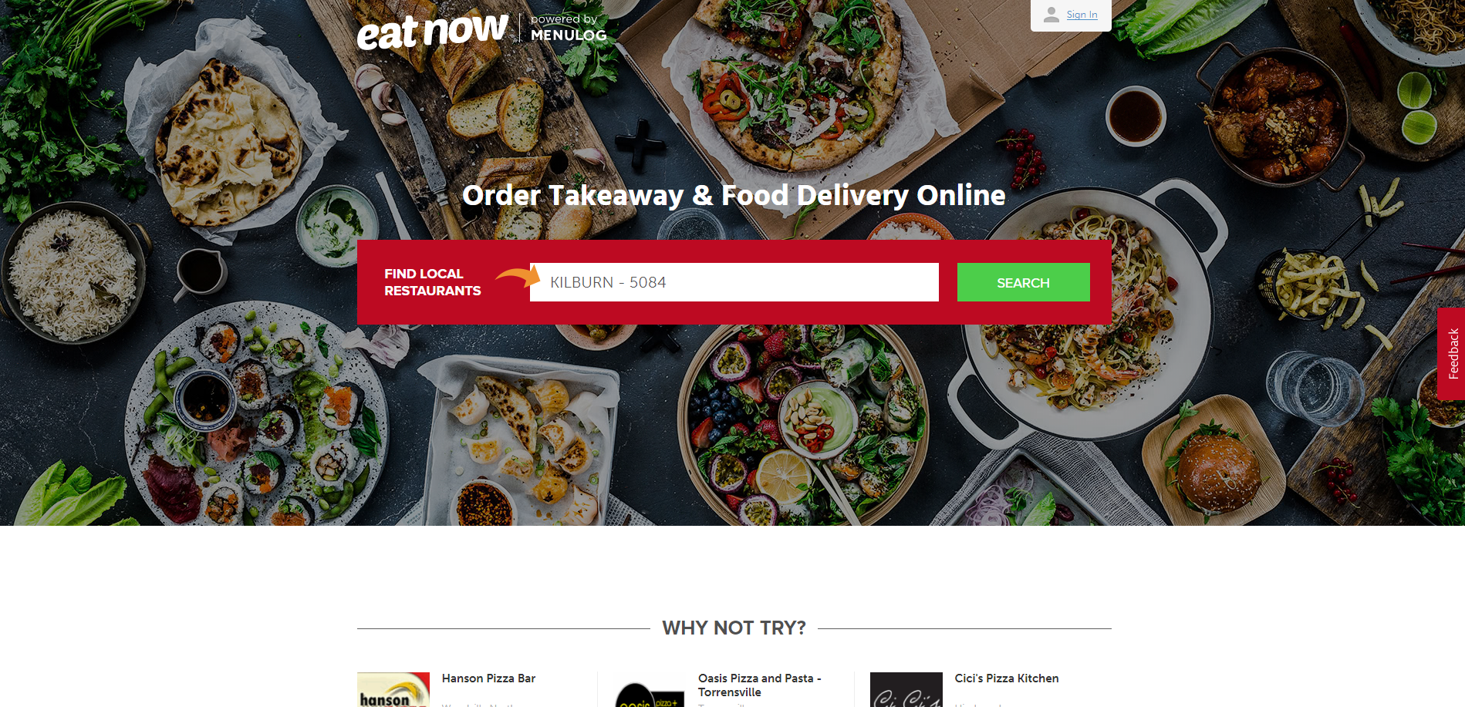

|  |  |
| --- | --- |
| Good | Bad |
| * Emphasised search bar with minimal input. * Dynamic actions are towards the top right as is standard (‘Sign In’). * Food photography as a visual appetiser. * Recommendations/examples. | * None with respect to a food delivery site. |

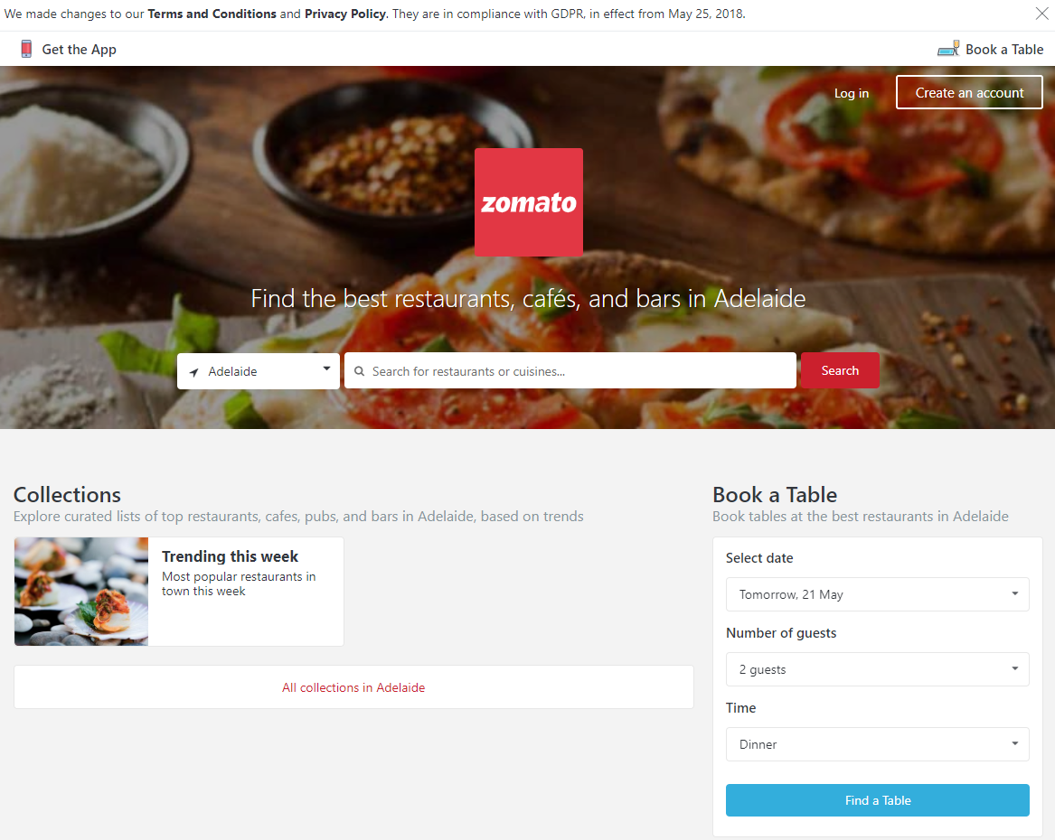

|  |  |
| --- | --- |
| Good | Bad |
| * Emphasised search bar with minimal input. * Dynamic actions are towards the top right as is standard (‘Sign In’). * Food photography as a visual appetiser. | * The separation of ‘Book a Table’ and the search bar is unnecessary. It would be better to combine the two, and provide sensible defaults for booking information inputs, or default them to ‘Unspecified’, where the value is ignored in the search query if the user does not alter them. * Unnecessary repetition of ‘Book a Table’ in the top right. |